**Lab Exercise 3 Integrate Maven with Jenkins**

Step 1: Installing Maven plugin

1.1 Open the browser, and go to Jenkins dashboard by typing localhost:8080 in your browser

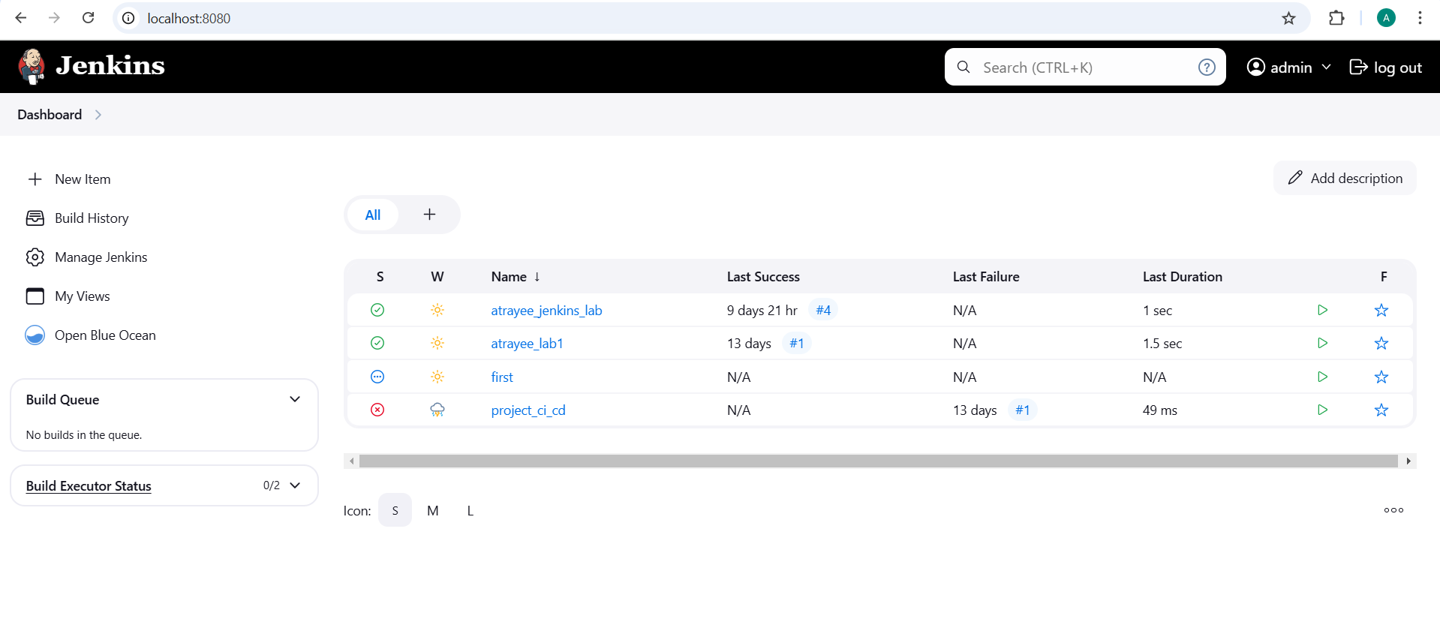

1.2 Provide the credentials, and click on Sign in.

1.3 Click on Manage Jenkins. From the list of options, choose Manage Plugins.

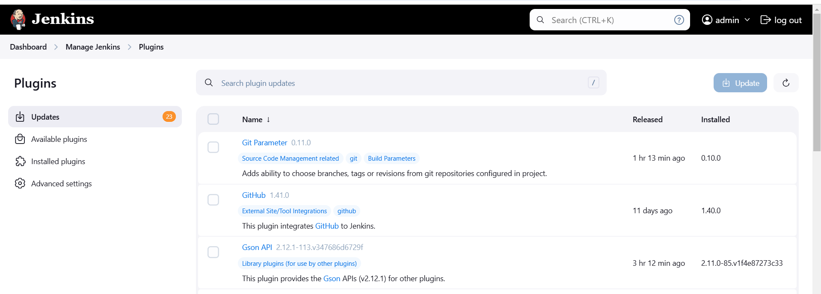

1.4 Under the Available tab, search for Maven plugin.

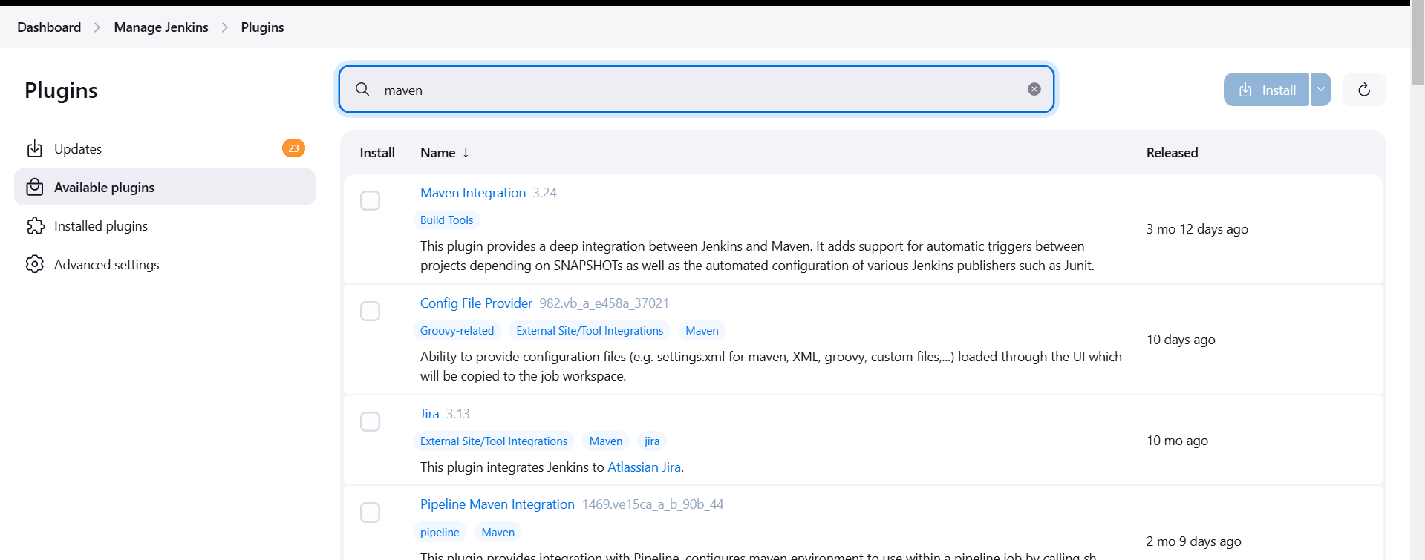

1.5 Select the checkbox in front of the Maven Integration plugin, and click on the Install without restart button.

1.6 The Maven plugin will get installed.

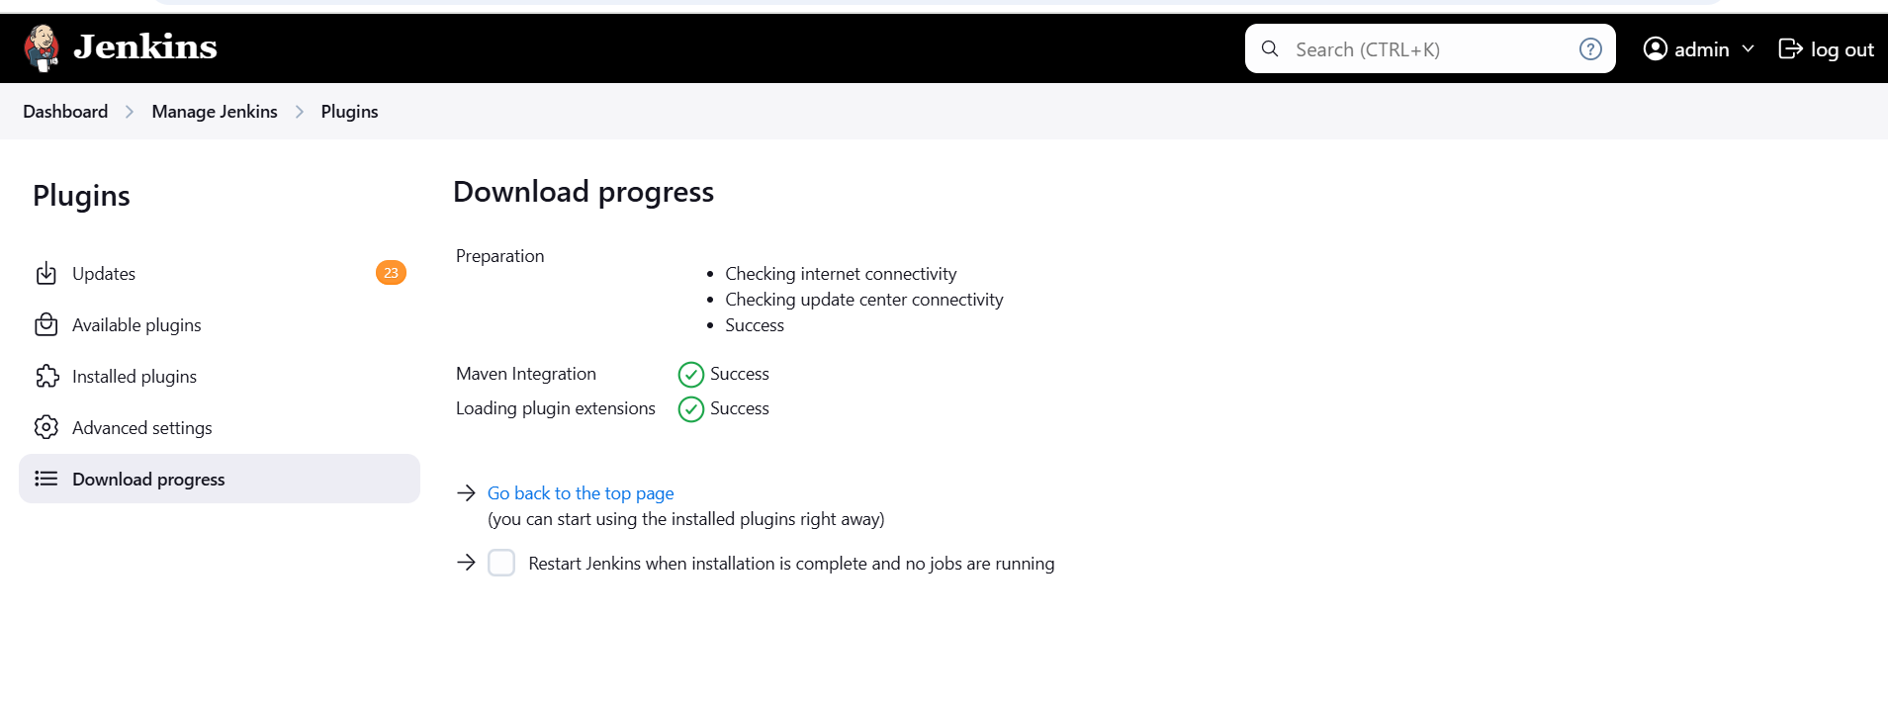

mvn -version

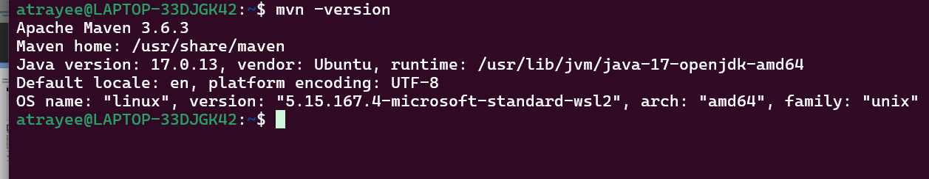

Step 2: Setting the Global Tool Configuration

2.1 Go to Jenkins Dashboard, click on Manage Jenkins. From the list of options, choose Global Tool Configuration.

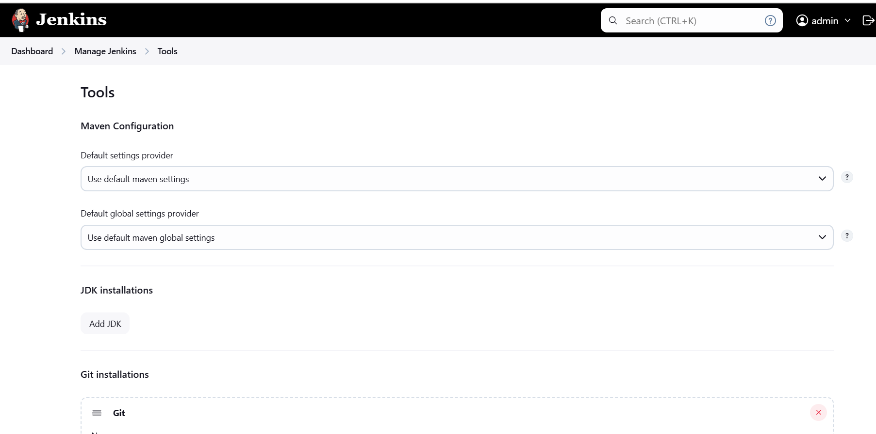

2.2 Click on Add JDK, and provide the Name and JAVA_HOME path. Uncheck the Install automatically checkbox.

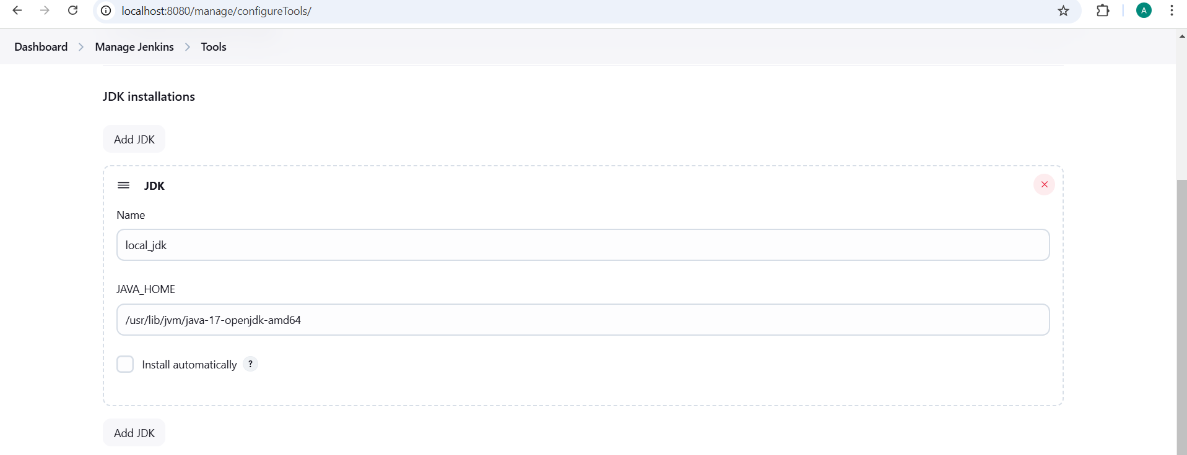

2.3 To configure Maven, click on Add Maven button in the Maven section, enter any Name and MAVEN_HOME path. And uncheck the Install automatically checkbox.

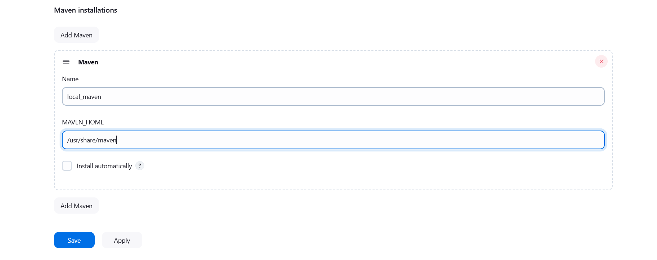

2.4 To configure Git, click on Add Git, and enter any Name and Path to Git executable path.

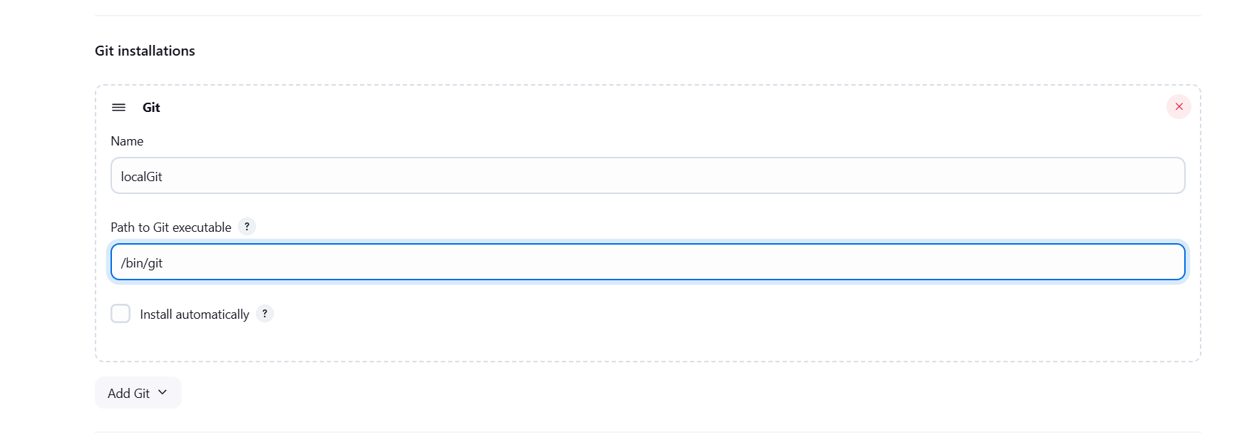

2.5 Click on Save.

Step 3: Forking a sample repository

3.1 Login to your Github account. 3.2 Navigate to https://github.com/jenkins-docs/simple-java-maven-app, and click on Fork.

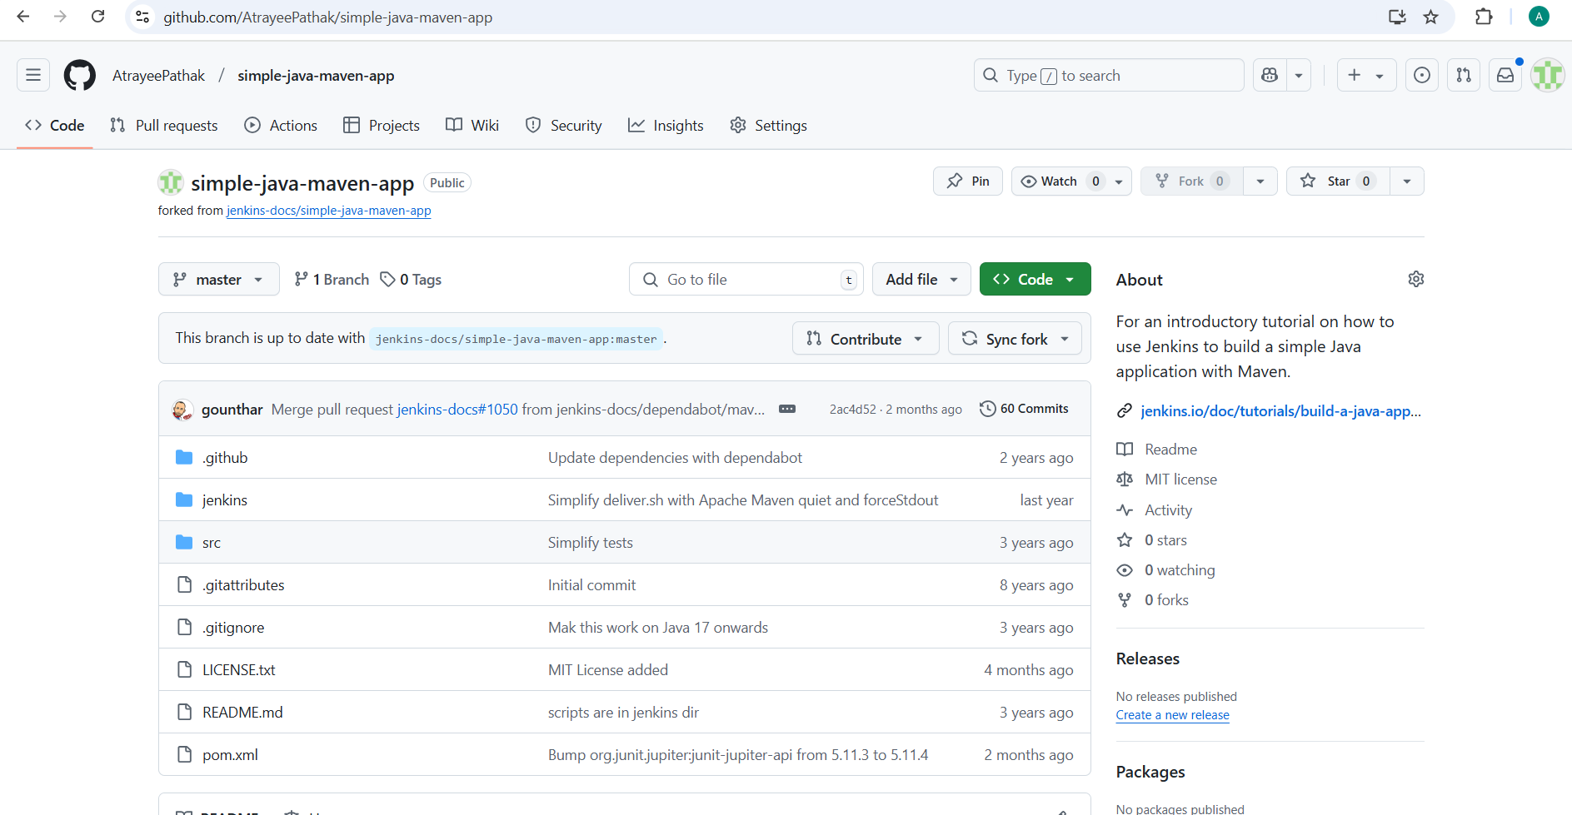

3.3 Open the terminal.

3.4 Run git clone [Forked_REPO URL] to clone the repo locally.

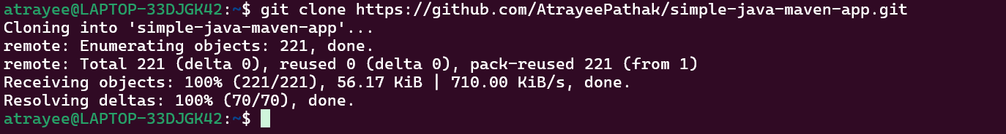

Step 4: Integrating Maven with Jenkins

4.1 Click on New Item in the Jenkins dashboard

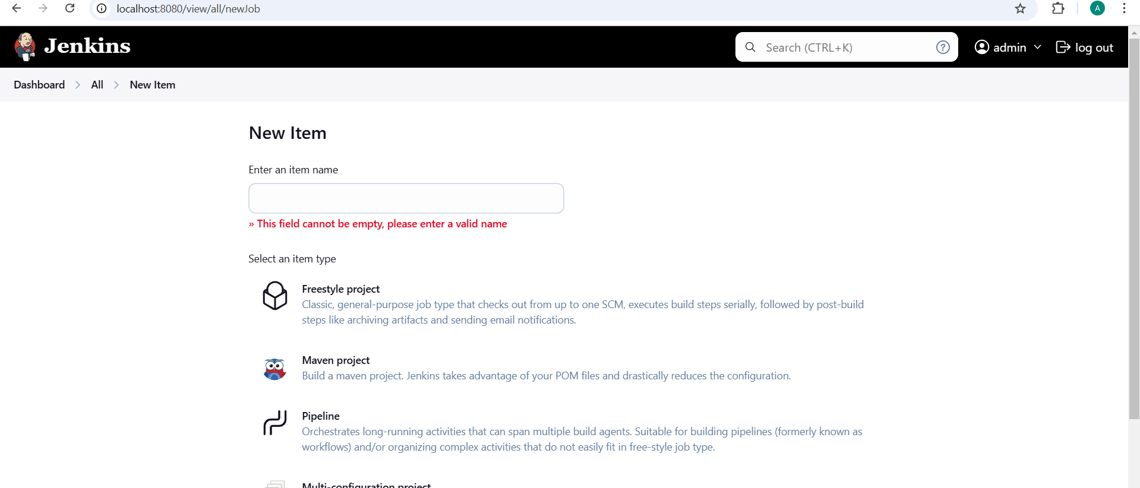

4.2 Enter a name for your project.

4.3 Select Maven project as the build job type.

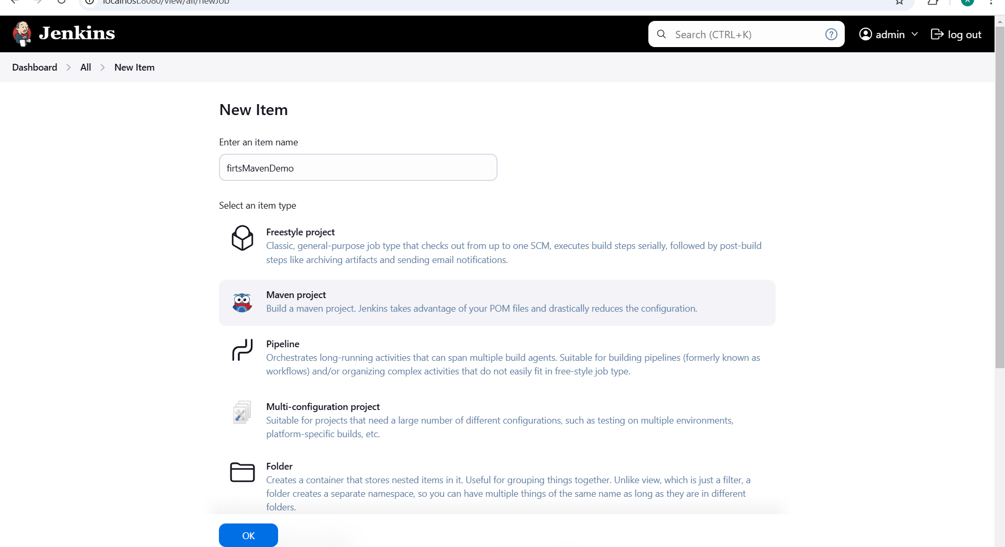

4.4 Click on OK.

4.5 Scroll down to the Source Code Management section, and select Git.

4.6 Enter the repository URL

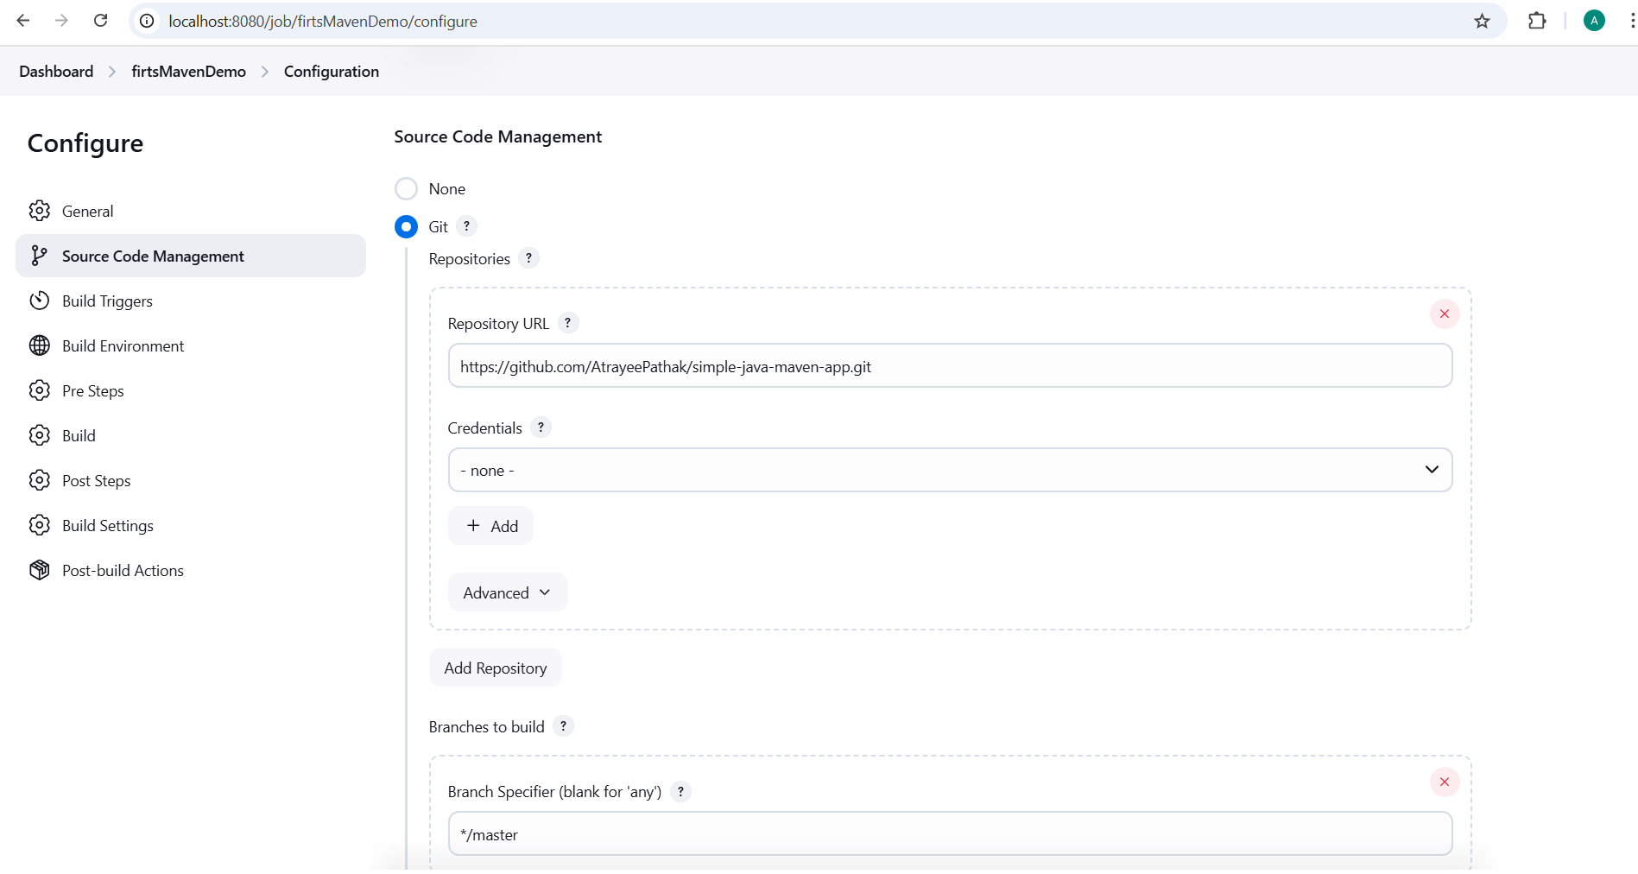

4.7 In the Build Triggers section, select the required option.

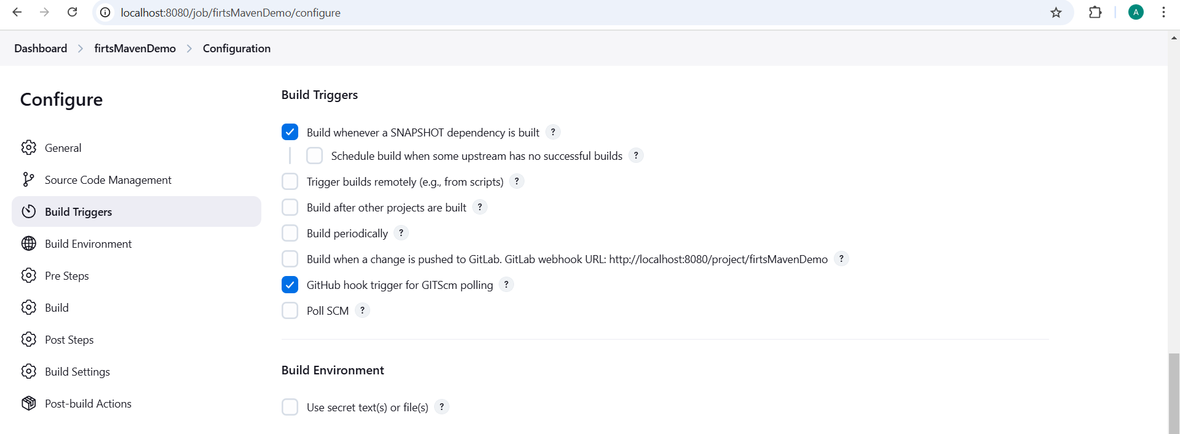

4.8 Click on Save.

4.9 Click on the Build History to view the build results.

4.10 Click on the Console Output to view the build logs.

